Design Report

HATGEMINI

Group Members:

Cosaro Lisa – 951884 – [lisa.cosaro@mail.polimi.it](mailto:lisa.cosaro@mail.polimi.it)

Kumar Pardeep – 965284 – [pardeep.kumar@mail.polimi.it](mailto:pardeep.kumar@mail.polimi.it)

Pinari Etion – 965175 – [etion.pinari@mail.polimi.it](mailto:etion.pinari@mail.polimi.it)

Ronzulli Michael – 953527 – [michael.ronzulli@mail.polimi.it](mailto:michael.ronzulli@mail.polimi.it)

Delivery date:

Link to the prototype:

Table of Contents

ABSTRACT 2

C-IDM DIAGRAM 3

CONTENT TABLES 5

MAPPING CONTENT TABLES INTO PAGES 7

P-IDM DIAGRAM 8

VISUAL DESIGN 9

INTERACTION SCENARIOS 12

DB DESIGN 13

# ABSTRACT

# 3-5 lines that describe what the document is about

# C-IDM DIAGRAM

Legend:

(T): Topics, (GOT): Group of Topics, (KOT): Kind of Topic, (MG): Multiple Groups

The content of our website is included into 4 main Kind of Topics (KOT):

* Area: This (KOT) contains areas of expertise which have employees working in them (exactly 3) and offer many services (exactly 2). It also contains a variable number of articles (from 1 to 3),
* Expert: Our employees have been defined in a (KOT) which are part of an area, might create certain services and might write many articles (up to 3),
* Service: This topic contains services or products we offer such as PaaS (e.g.: Hatgemini’s Stidia (T)) or SaaS (e.g.: Digital Entertainment Exchange (T))
* Article: This (KOT) contains articles published by one employee (1:1) regarding one (1:1) area of expertise.

The most relevant Groups of Topics (GOT) have been included in the form of groups of:

* All Areas: The section of our website presents all our (KOT) areas of expertise, such as (T) `Gaming and Entertainment` or (T) `Energy and Utilities` etc.
* All Experts: The section of our website presents all our (KOT) employees of different areas. Furthermore, we found a useful semantic grouping of employees of that work in the same area (MG).
* All Services: This part of our website is where we place the products or services that we offer such as (T) ‘Next-Gen AMI’.
* All Articles: This portion of our website will offer many interesting area-specific pieces of writing.

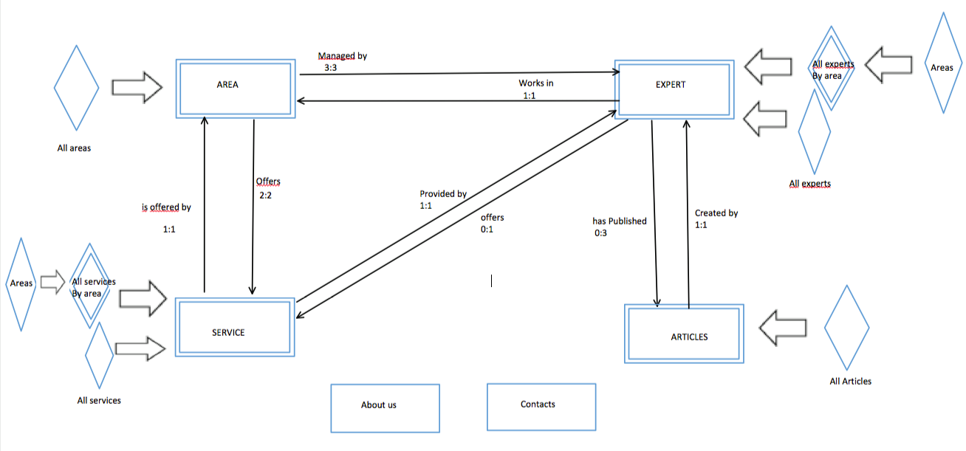

# CONTENT TABLES

The following are all the content tables derived from the C-IDM:

***Kinds of topics***

|  |
| --- |
| **Kind of Topic: Expert** |
| Full name: text (max 4 words) |
| Expert's picture: image |
| Short bio: text (max 50 words) |
| Author’s life: text (max 200 words) |

|  |
| --- |
| **Kind of Topic: Service** |
| Title: text (max 30 char) |
| Service image: image |
| Short overview: text (max 50 words) |
| More details: text (max 200 words) |

|  |
| --- |
| **Kind of Topic: Area** |
| Title: text (max 30 char) |
| Area image: image |
| Short overview: text (max 50 words) |
| More details: text (max 200 words) |

|  |
| --- |
| **Kind of Topic: Article** |
| Title: text (max 60 char) |
| Article image: image |
| Subtitle: text (max 50 words) |
| Content: text (max 400 words) |

***Groups of topics***

|  |
| --- |
| **Group: “All Areas”** |
| Title: text (max 30 char) |
| All areas image: image |
| Short overview: text (max 50 words) |
| Area Preview: LIST OF [Area’s title, Area’s image] |

|  |
| --- |
| **Group: “All Services”** |
| Title: text (max 30 char) |
| All services image: image |
| Short overview: text (max 50 words) |
| Service Preview: LIST OF [Service’s title, Service’s image] |

|  |
| --- |
| **Group: “All Articles”** |
| Title: text (max 30 char) |
| Article Preview: LIST OF [Article’s Title, Article’s Image, Article’s short preview] |

|  |
| --- |
| **Group: “All Experts”** |
| Title: text (max 30 char) |
| All expert’s image: image |
| Experts preview: LIST OF [Expert’s full name, Expert’s Image, Expert’s area] |

***Multiple Groups***

|  |
| --- |
| **Multiple Group: “All Experts by Area”** |
| Title: text (max 30 char) |
| Experts preview: LIST OF [Expert‘s Image, Expert‘s full name, Expert’s area] |

|  |
| --- |
| **Multiple Group: “All services by Area”** |
| Title: text (max 30 char) |
| Services preview: LIST OF [Service‘s Image, Service‘s title] |

|  |
| --- |
| **About us** |
| Information: text (max 200 words) |

***Unique pages (Topics)***

|  |
| --- |
| **Contacts** |
| Title: text (max 30 char) |
| Information: text (max 100 words) |
| Form to fill out |

# MAPPING CONTENT TABLES INTO PAGES

Auto explanatory.

# P-IDM DIAGRAM

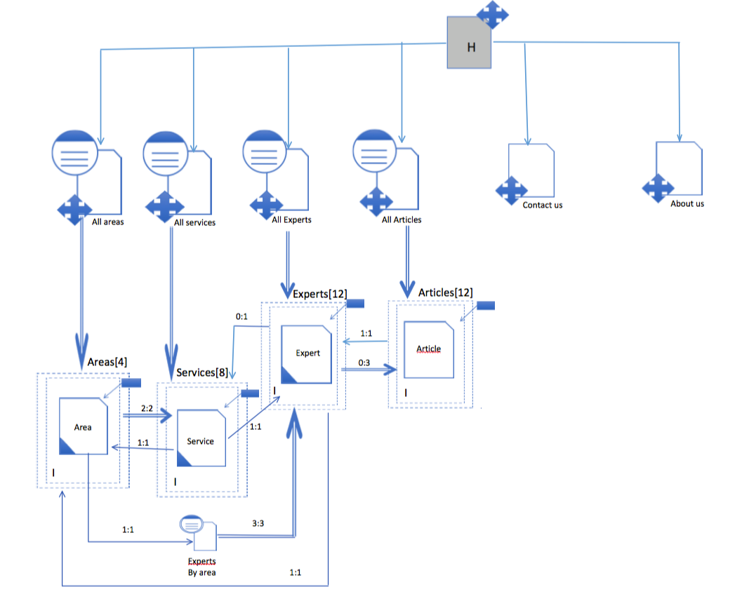

# VISUAL DESIGN

* PAGE STRUCTURES

Example: For all the pages the navbar misses article button. Footer should say it contains links to social media websites. **(ADD CONTACT US PAGE WIREFRAME and IMAGE IN ABOUT US WIREFRAME)**

Kind of Topic pages: **(Add articles kind-of-topic page wireframe)**

**(Non le ho aggiunte ma ce ne sono da mettere le pagine `TOPIC` di experts, areas, services e articles.)**

# INTERACTION SCENARIOS

Our website is thought to be used by many groups with the same common interest, it being technology. Whether the user is a person who is interested in modern methodologies of solving current tech-problems, a business- inquirer trying to know more about Hatgemini’s offered services or someone who would like to be in contact with the group regarding other technology related issues, there is a part of the site dedicated to each one of them.

The following are a few of the possible use cases of our website:

a) An Energy Engineer visits the website and sees the homepage. Inside the homepage, his attention is drawn by the Area denominated ‘Energy and Utilities’.

**\*INSERT IMAGE OF HOMEPAGE WITH AREA HIGHLIGHTED\***  
He clicks on the link showed above and sees all the services provided in this area from our company.

**\*INSERT IMAGE OF AREA PAGE WITH ONE SERVICE HIGHLIGHTED\***

Since the title of the service entices his curiosity, he clicks on the service and reads what we offer regarding the problem.

b) A businesswoman wants to use our company’s services of **\*\*TELECOMMUNICATION(?)\*\***, and after having scrolled past a few of our services decides to contact us.

**\*INSERT IMAGE OF SERVICE PAGE WITH CHATBOT HIGHLIGHTED\***

She writes to the chatbot, telling it that she wants to contact us through our mail-information. The interaction is the following:

**\*INSERT IMAGE OF CHATBOT INTERACTION\***

The chatbot then redirects her to the ‘contacts’ page.

c) A student would want to know more about what our employees have discovered in their years of work regarding, in this specific case, ‘Gaming and Entertainment’. After having read about a few of our employees and their biographies, she clicks on one article that our employee has posted.

**\*INSERT IMAGE OF employee/9 AND HIGHLIGHT ONE ARTICLE\***

She then can read what our employee thinks of her favourite videogame.

**\*INSERT IMAGE OF ARTICLE AND HIGHLIGHT BACK BUTTON\***

# DB DESIGN

Our database is a simple translation of the C-IDM and Content tables into PostgreSQL. The primary keys have been emitted because they are assigned automatically by the database. The primary keys of each entity are ordered, increasing numbers starting from 1. We have decided not to store the images as LOB, but instead to refer to them as links.

For the entities Area and Service:

* Title is the name of the entity,
* Overview is a brief explanation of what to expect from that entity,
* 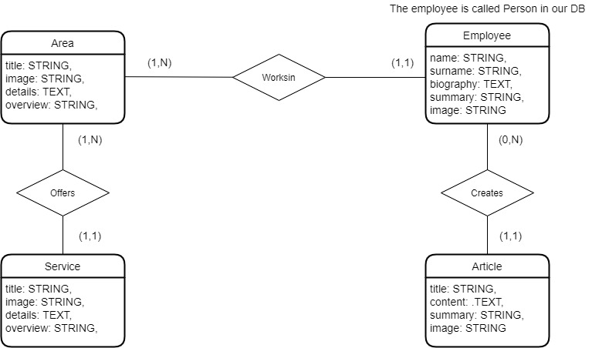Details is the attribute that contains a longer text that talks about the entity.

The relationships between entities and the other attributes are self-explanatory.